Sleep Quality Predictor
An AI-Driven Wellness Tool for Sleep Health Optimization
Author: Artheesh E
Project Type: Individual Project

1. Executive Summary
The Sleep Quality Predictor is a Machine Learning-based application designed to analyze the intersection of lifestyle habits and physiological factors to determine sleep health. Recognizing that poor sleep is fundamentally linked to chronic conditions like heart disease, obesity, and reduced productivity, this project provides users with a data-driven approach to monitor and improve their rest.

2. Project Objective & Scope
- Goal: To build a predictive model that classifies sleep quality as Good, Average, or Poor based on daily behavioral data.
- Target Audience: Individuals seeking actionable insights to optimize their sleep hygiene and overall mental well-being.
- Core Logic: The system uses supervised machine learning to identify key patterns in user-submitted habits like exercise, caffeine intake, and screen time.

3. Technical Implementation
The project leverages a robust Python-based stack to process health data and generate predictions.
A. Technology Stack
- Language: Python.
- Data Processing: Pandas and NumPy for cleaning and managing datasets.
- Machine Learning: scikit-learn for training and evaluating predictive models.
- Visualization: Matplotlib and Seaborn to illustrate sleep trends and factor correlations.
- Algorithms: Random Forest, Decision Tree, Logistic Regression, and SVM.
B. Data Sources
The model is grounded in real-world health data, utilizing:
- Sleep Health and Lifestyle Dataset (Kaggle).
- Sleep Efficiency Dataset (UCI Machine Learning Repository).
SOURCE CODE IMPLEMENTATION (Screenshot):

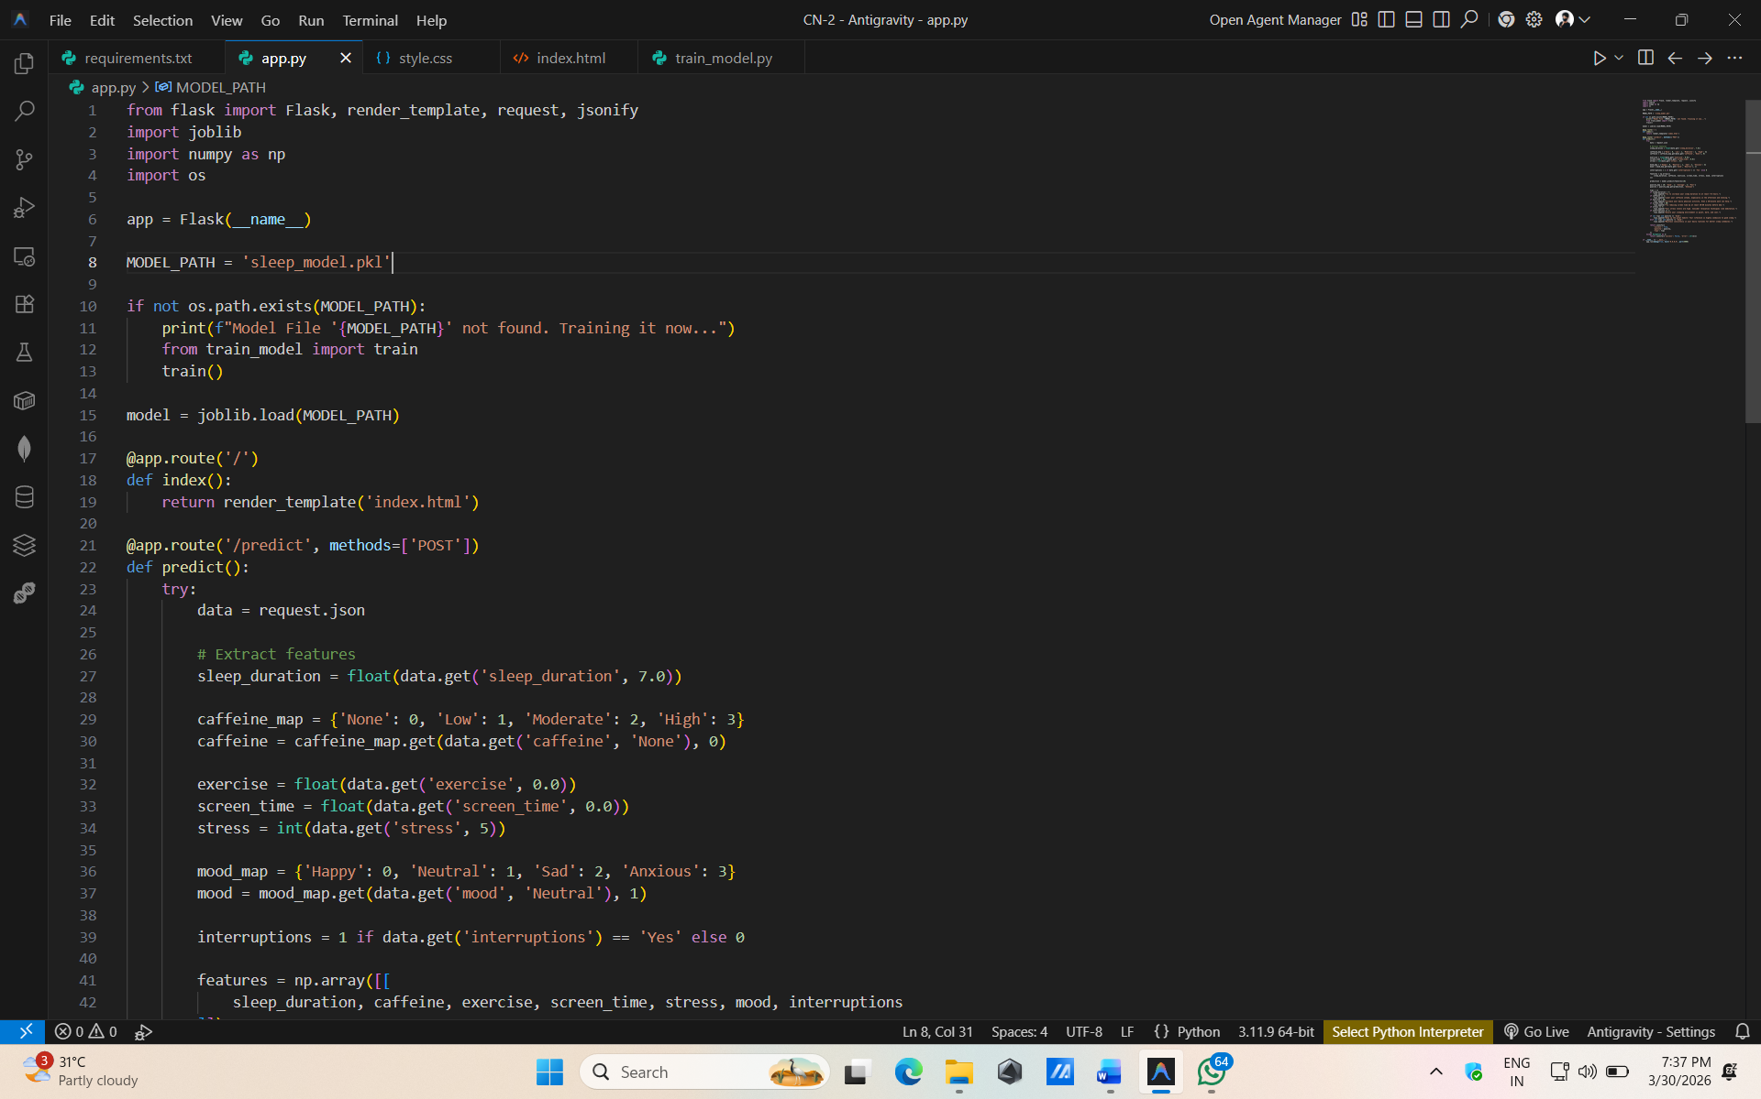
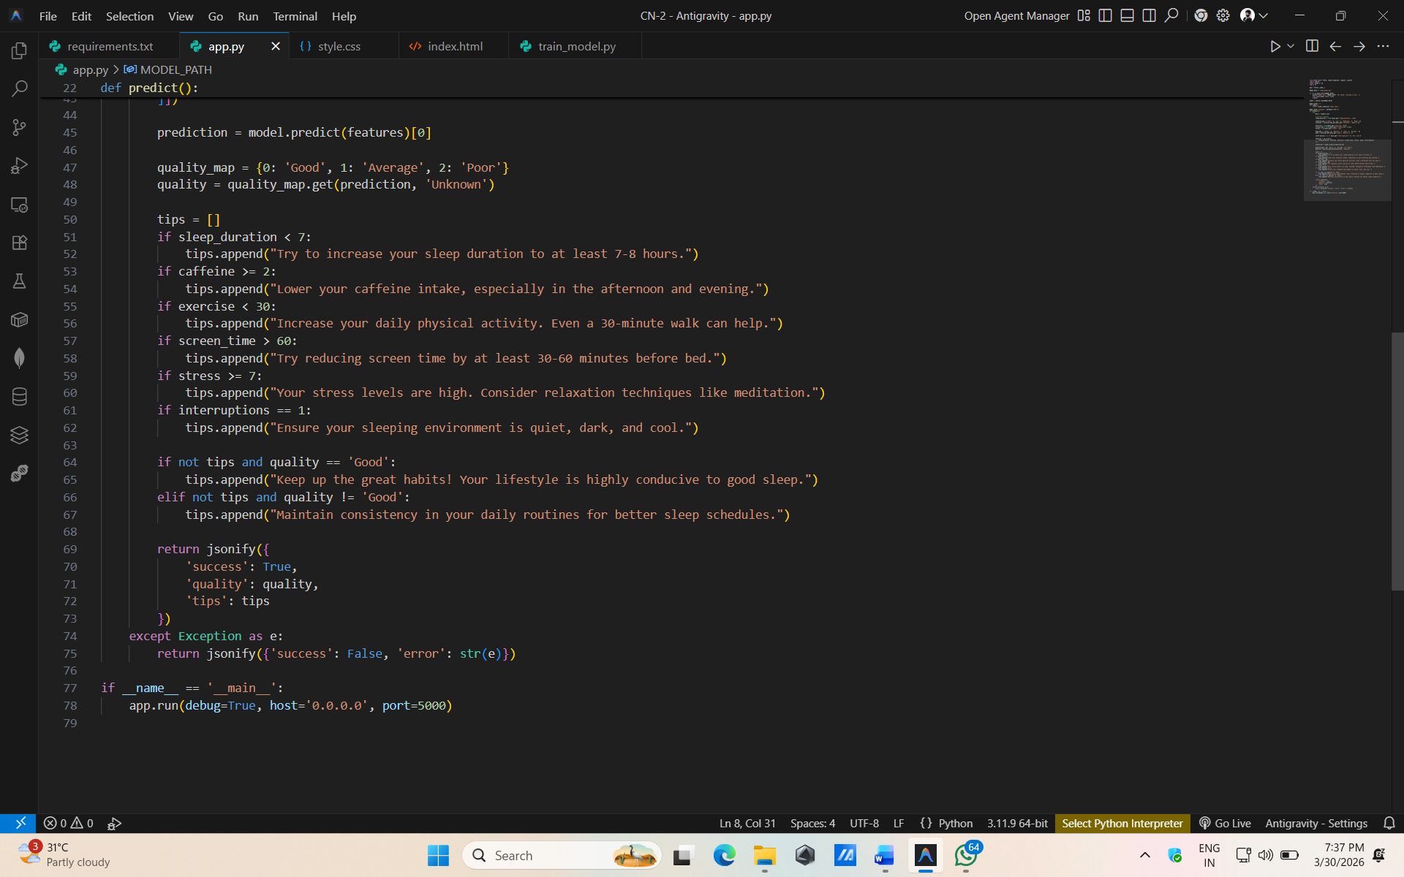

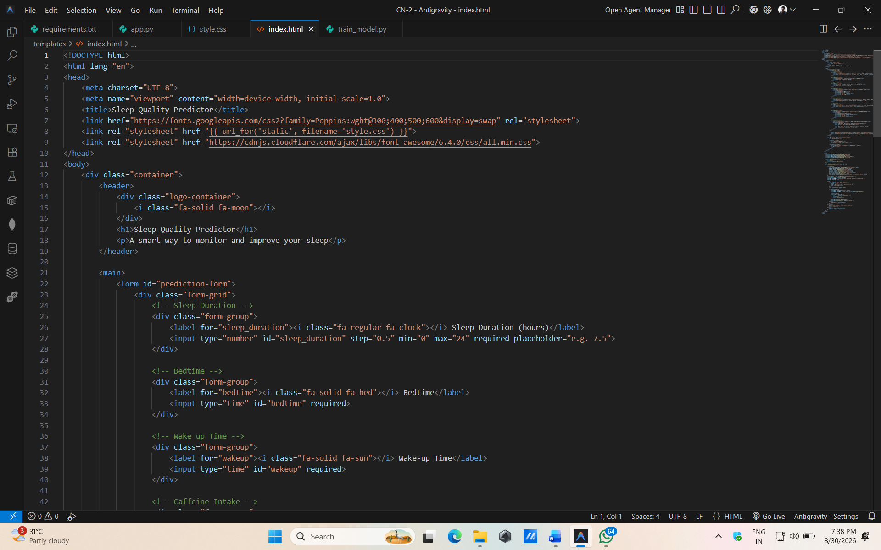
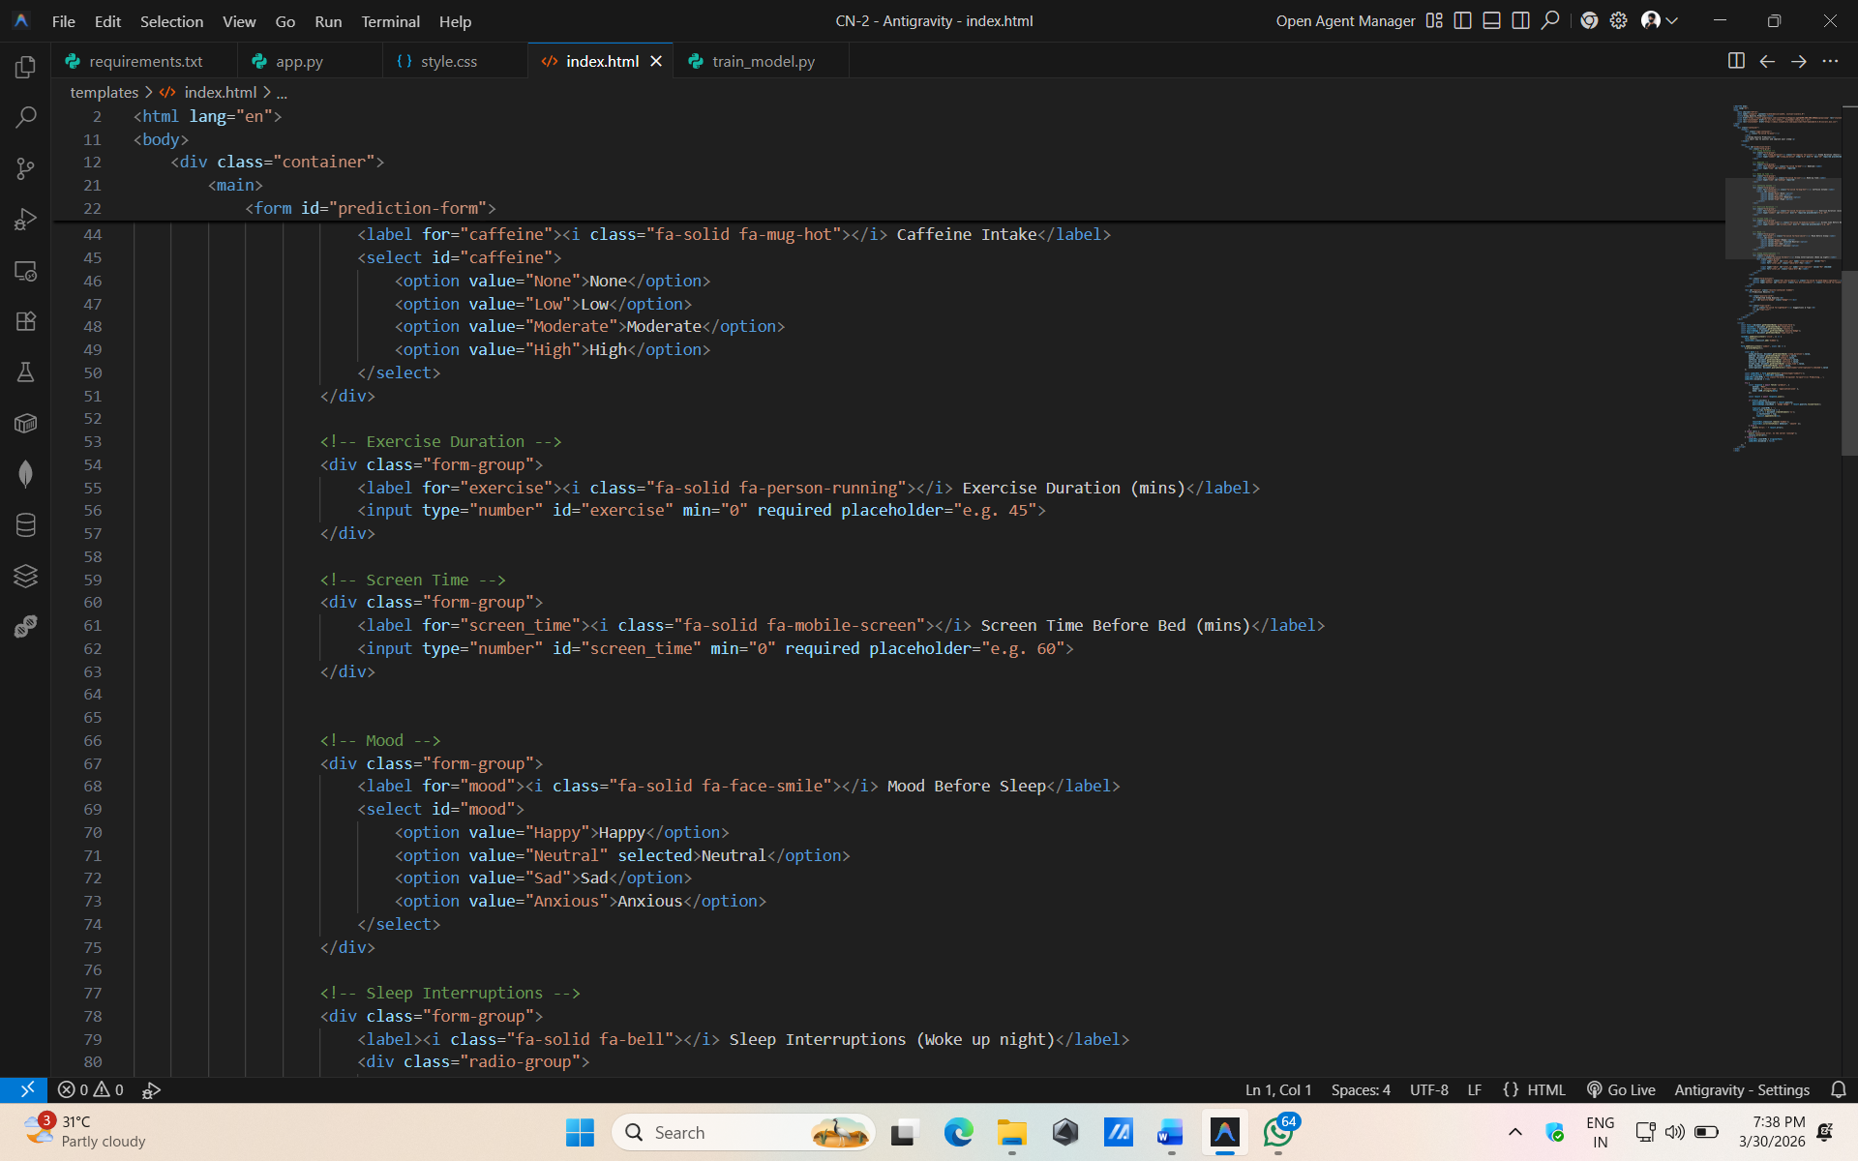

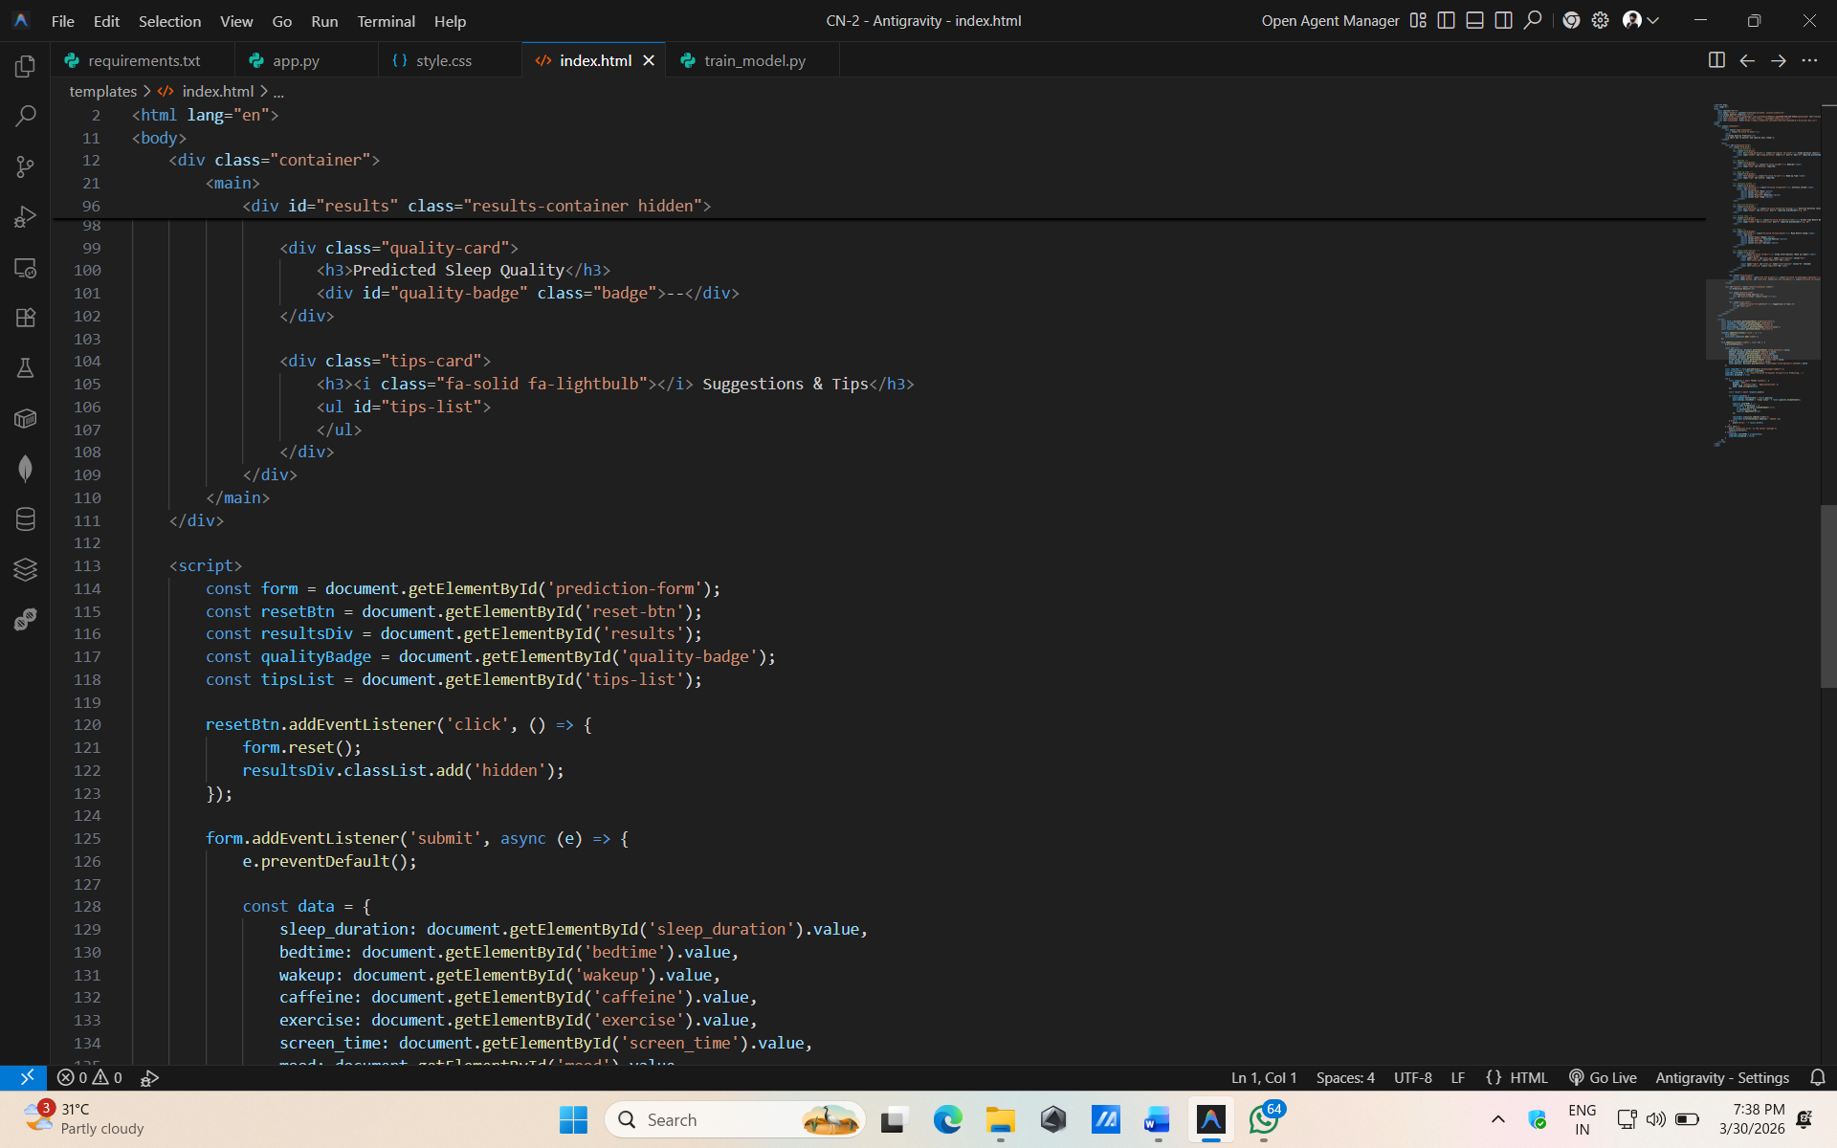
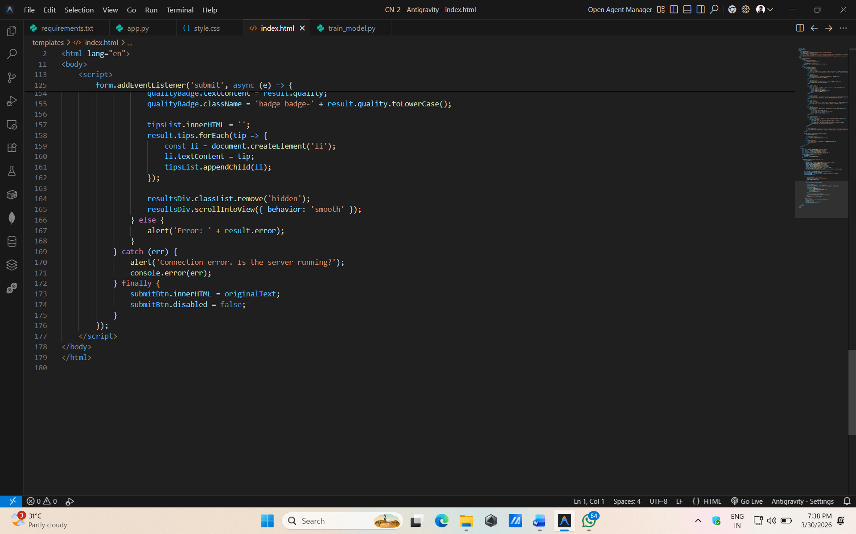

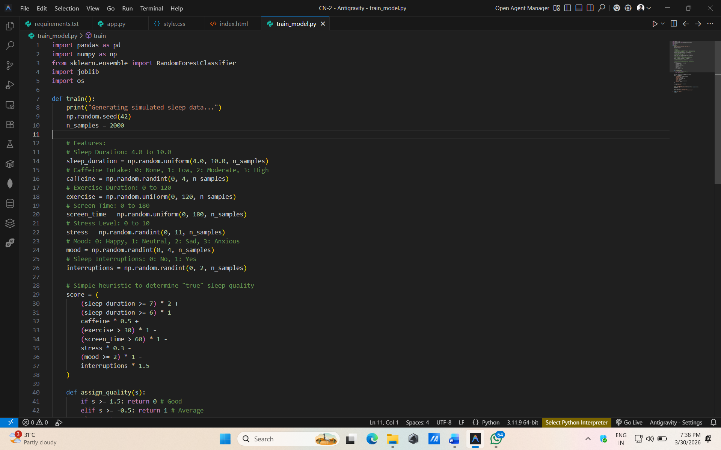
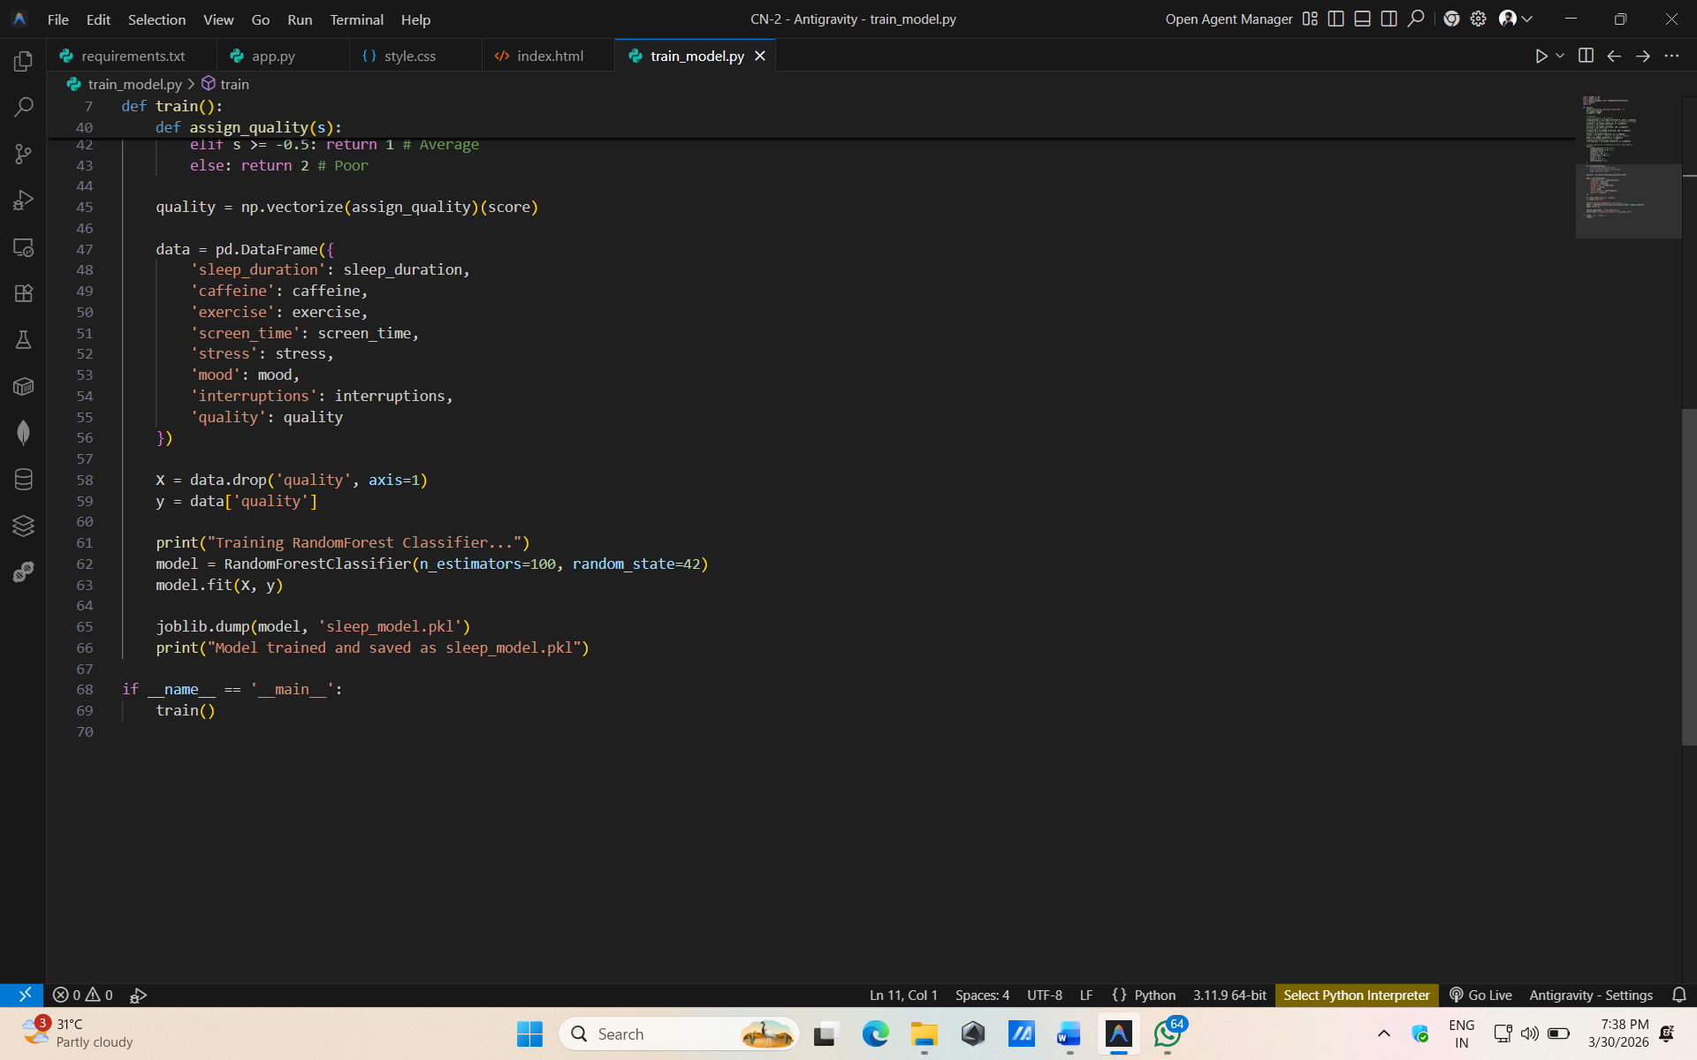

RESULT
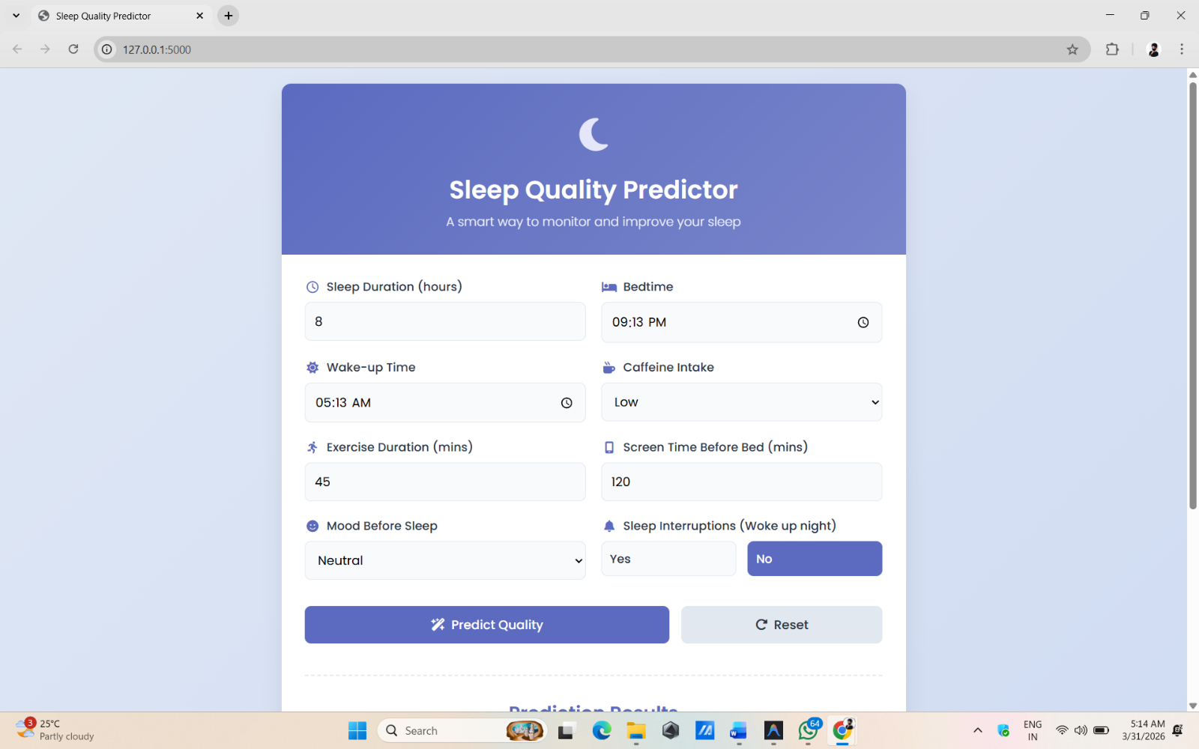

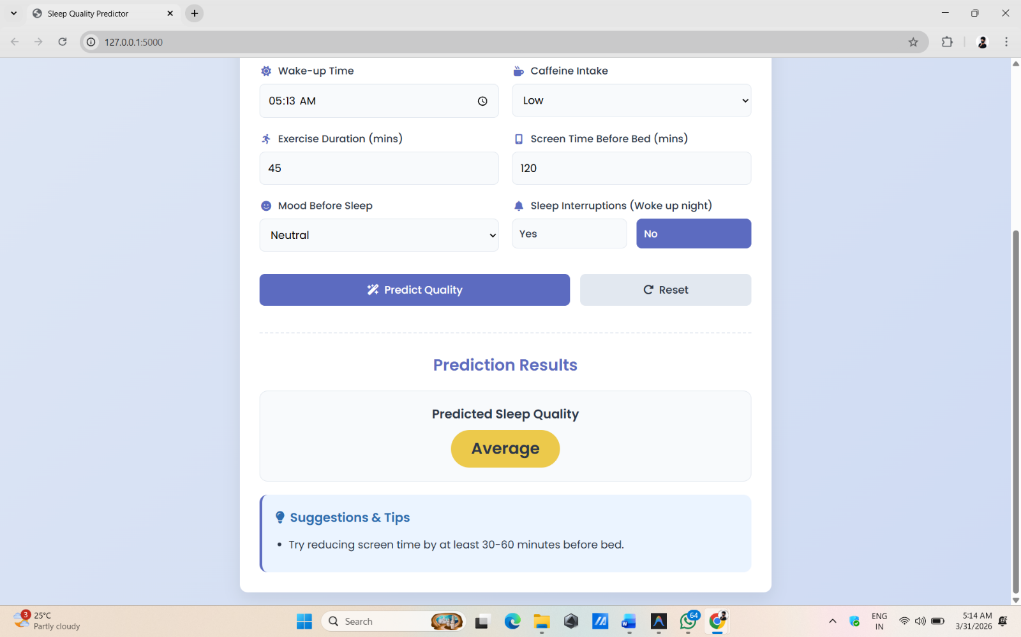

4. System Features & User Interface
The application is designed with a "calm" aesthetic, utilizing soft blues and purples to reflect a sleep-related environment.
Key UI Components:
- Behavioral Inputs: Users provide data on sleep duration, bedtime, wake-up time, and caffeine consumption.
- Lifestyle Inputs: Numeric inputs for exercise duration and screen time, alongside a 0–10 slider for stress levels.
- Actionable Insights: Upon prediction, the system provides personalized tips, such as reducing screen time or increasing physical activity.
- Trend Tracking: An optional history section displays past sleep scores and charts to visualize improvements over time.

5. Project Outcomes
- Predictive Accuracy: Successfully built a model capable of evaluating sleep quality using real-world health metrics.
- Factor Identification: Helped isolate critical triggers for poor sleep, such as high stress levels and excessive late-night screen usage.
- Behavioral Change: Encouraged proactive habit tracking, laying a foundation for future mobile wellness integrations.
- Data Analytics Mastery: Enhanced the developer's understanding of behavioral data modeling and health-centric AI applications.

6. Conclusion
The Sleep Quality Predictor serves as a vital bridge between daily habits and long-term health outcomes. By combining clear UI design with powerful supervised learning, the project offers a scalable foundation for modern smart-sleep applications and health monitoring tools.

